3GPP TSG RAN WG1 Meeting #125 R1-2603874
Dalian, China, May 18-22, 2026

Agenda item: 10.8.2
Source: Cohere Technologies
Title: On integration of sensing with communication in 6GR
Document for: Discussion and Decision

1 Introduction
Two of the agreements in RAN1#124bis were the following:
___________________________________________________________

Agreement:
- On RS for ISAC, study at least the following aspects, considering sensing performance, resource overhead and impact to communication
  - RS for communication is reused for sensing
  - Enhanced RS for sensing, taking reuse of RS for communication as starting point
    - Note: Part of or all of the RS may be used for communication purpose, and it does not mean the final decision on whether the enhanced RS is used for communication purpose is to be made in this agenda.
  - Dedicated RS for sensing

Agreement:
- Study RE patterns of RS for sensing, considering sensing performance, resource overhead and impact to communication
- Note: enhancements on RS sequence if any will be discussed in agenda 10.8.3
___________________________________________________________

In addition, the FL included the following topics for discussion in RAN1#125:

___________________________________________________________

- RS design
  - Please elaborate designs on sensing RS especially the RE patterns.
  - Please provide evaluations/analysis.
- Based on discussions in this meeting (though no agreements yet), the inputs on the following aspects can be considered which is up to each company.
  - Resource allocation/multiplexing
  - Phase continuity within a CPI
  - Beam related sensing operations
  - Interference handling
  - Power control
  - Timing advance
  - Sensing Tx/Rx node selection, if any, from RAN1 perspective
  - Start/end/activation/deactivation of sensing operations, if any, from RAN1 perspective
___________________________________________________________

In this contribution we present a dedicated RS for sensing which we refer to as sensing signal. This signal is an ISAC waveform overlayed over the communication waveform (4G, 5G, 6G, WiFi, etc.), is low complexity, adds no overhead, and provides full flexibility to the receiver to choose the Doppler resolution per sensing event.

2 Proposed ISAC solution
Our proposed ISAC system addresses the following issues in current state-of-the-art ISAC systems, namely, (i) sensing signal overhead and loss in spectral efficiency achieved by communication terminals, (ii) high complexity of mitigating strong self-interference from radar transmitter to radar receiver, and (iii) communication standard specific sensing-signal design which for example, limits the degree of freedom in choosing the desired delay and Doppler resolution.

In this proposal, the sensing signal is overlayed as a weak signal on the existing communication signal and hence does not require any share of resources allocated to the communication signals, resulting in no sensing overhead. In addition, the communication terminals can use the sensing signal to acquire the complete channel response to reduce the overhead of channel estimation pilots in the communication signal in high delay/Doppler scenarios. This will further improve the effective spectral efficiency achieved by communication terminals.

There are two versions of the proposed ISAC system, one is implemented as a pilot of Zak-OTFS-over-CP-OFDM as described in ‎[2] and Figure 1 and the other as a pilot of a pure Zak-OTFS as described in ‎[3] with an example implementation in Figure 2. The time domain representations of the two sensing signals are shown in Figure 3 and Figure 4.

Figure 1: Block Diagram of a Transmitter for Zak-OTFS-over-OFDM based ISAC

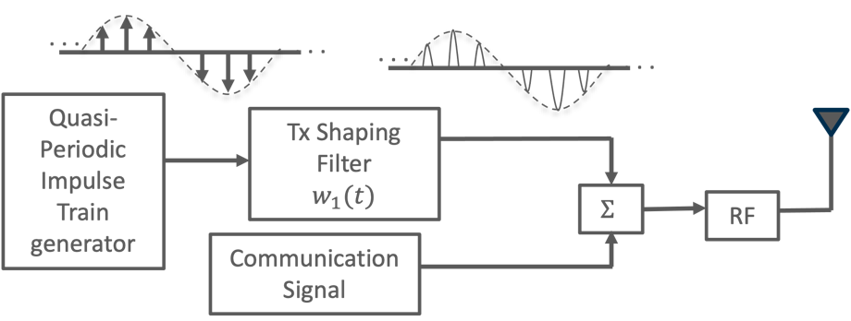
Figure 2: Block Diagram of a Transmitter for pure Zak-OTFS based ISAC

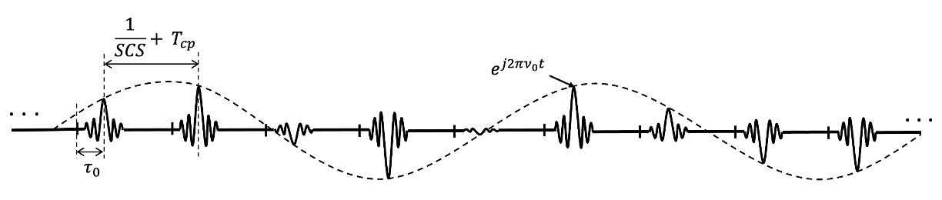
Figure 3: Time domain of sensing signal using Zak-OTFS-over-CP-OFDM

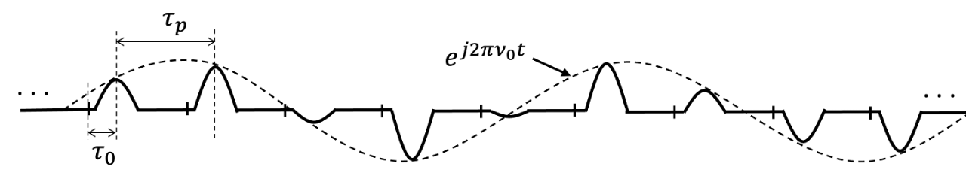
Figure 4: Time domain of sensing signal using pure Zak-OTFS

In the delay-Doppler domain the sensing signal is a single dirac delta located in one of the MxN REs of the delay-Doppler grid. This signal, in the case of Zak-OTFS-over-CP-OFDM goes through a sinc filter in the time domain (by going through the CP-OFDM modulator). In the case of pure Zak-OTFS the filter is a design choice. In both cases the signal in the time domain is an infinite pulse train of a Dirac delta convolved with a filter.

Observation 1: The sensing signal based on overlaying of pure Zak-OTFS pilot or Zak-OTFS-over-OFDM pilot over the communications signal is agnostic to the communication signal and can share the time-frequency resources with any communication waveform (4G, 5G, WiFi, etc.)

The sensing receiver for the Zak-OTFS-over-OFDM pilot is presented in ‎[2] and ‎[3]. The receiver for the pure ZAK-OTFS pilot is presented in ‎[3] and Figure 5. This receiver is simpler as the transfer from the time domain to the delay-Doppler domain is done directly using the Zak transform. This ISAC system has advantages over using OFDM-based reference signals as shown in ‎[2] and ‎[3] and since it is an overlay over the communication signal it can be easily integrated with the communication.

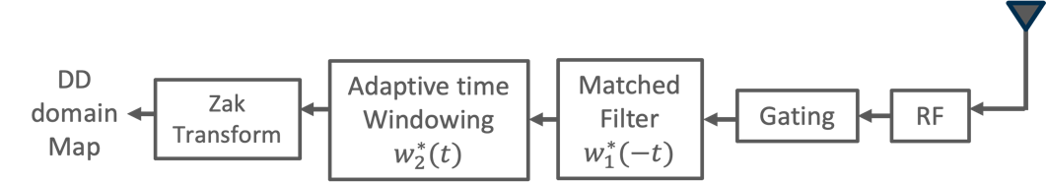
Figure 5: Block Diagram of a Receiver for pure Zak-OTFS based ISAC
Observation 2: An ISAC system based on pure Zak-OTFS can be seamlessly integrated with the communication without adding overhead and without impacting the performance of the communication signal while meeting and exceeding the sensing requirements.

3 Discussion

3.1 RS design
For both cases pure Zak-OTFS pilot and Zak-OTFS-over-CP-OFDM pilot used for sensing, the signal in the delay-Doppler domain is a single Dirac delta placed on one of the delay-Doppler grid points as shown in Figure 6, where the delay period $τ_{p}$ is of the dimension $M$ which can be configurable and the Doppler period $ν_{p}$ is of dimension $N=∞$.

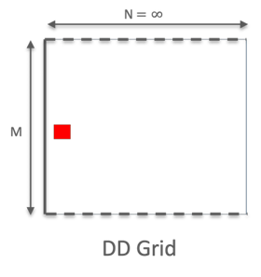
Figure 6: Sensing Dirac delta in the delay-Doppler domain

In the case of Zak-OTFS-over-CP-OFDM, the delay-Doppler domain signal is transferred to the T-F domain through IDZT followed by M-point DFT resulting in a signal that is spread over both frequency and time dimensions as shown in Figure 7. This signal is then (after it is overlayed over the data) modulated using a standard CP-OFDM modulator. In the time domain this sensing signal looks as shown in Figure 3. The offset positions of the pulses in time are set by $τ_{0}$ (the position in the delay dimension), the distance between the pulses when M is equal the number of subcarriers is equal to $1/SCS+CP$, and the frequency of the phase rotation of the pulse train is $ν_{p}$.

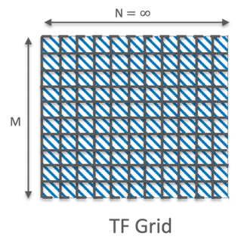
Figure 7: Time-frequency representation of the delay-Doppler generated sensing Dirac delta

In the case of pure Zak-OTFS, the sensing signal can be implemented directly in the time domain as a quasi-periodic pulse train as shown in Figure 4 where the offset positions of the pulses in time are set by $τ_{0}$ (the position in the delay dimension), the distance between the pulses is equal to $τ_{p}$, and the frequency of the phase rotation of the pulse train is $ν_{0}$.

3.2 Resource allocation and multiplexing
Our proposed sensing signal is a pulse train that may be positioned anywhere within a slot based on its placement in the delay-Doppler grid. This doesn't affect the communication signal as the power of the sensing signal is much lower than the communication signal and can be treated as noise. For multi-TRP sensing the sensing signals are multiplexed in the delay domain with enough separation to keep them orthogonal.
We showed in ‎[2] and ‎[3] that our proposed sensing solution meets the sensing requirements while having almost no impact on the communication performance. Based on that and observations 1 and 2 above we make the following proposal:

Proposal 1: ISAC solutions based on overlaying the sensing signal (e.g. Zak-OTFS pilot) over the communication signal will be included in the ISAC study for 6G.

3.3 Phase continuity
For our proposed sensing signal that is based on Zak-OTFS (Pulsone) overlayed at low power over the communication signal there is no issue of phase discontinuity within a CPI. Any proposed sensing solution that introduces a phase discontinuity should provide detailed explanation of the implications and how to address it.
Observation 3: An ISAC system based on Zak-OTFS overlayed over the communication signal doesn't experience phase discontinuity
Proposal 2: Sensing solution proposals that introduce a phase discontinuity should provide detailed explanation of the implications and how to address them.

3.4 Interference handling
The processing gain achieved with our proposed sensing solution by integrating the sensing signal over the BW and CPI is enough to handle the self-interference from the transmitted data and deliver good sensing performance as shown in ‎[2] and ‎[3]. Interference from adjacent cells is much lower than the self-interference and hence are not an issue. Sensing signal interference from adjacent cells is avoided by multiplexing the sensing signal in the delay dimension as stated in clause 3.2.
Observation 4: An ISAC system based on Zak-OTFS overlayed over the communication signal easily handles both self-interference and interferences from adjacent cells.
Proposal 3: The evaluation of sensing solution proposals should include the simulation of both self and adjacent cells interferences.

3.5 Power control
To provide flexibility to the MNOs enabling the sensing to trade off total signal power for sensing performance and/or shorter CPI, it is recommended to support a configuration for adjusting the sensing power.
Proposal 4: RAN1 to consider supporting the configuration of the sensing power

3.6 Sensing Tx/Rx node selection
The sensing procedures will always be controlled by the aNB and as such we see no need for RAN1 to specify how the Tx/Rx nodes will be selected. We propose the following:
Proposal 5: RAN1 will leave the Tx/Rx node selection to implementation

3.7 Activation/Deactivation of sensing operation
At this stage of the study it is too early to define the mechanism to activate/deactivate the sensing operation. Our recommendation is that part of the study the proponents of specific sensing mechanisms will describe how to activate/deactivate/start/end their sensing operation. Our proposed sensing mechanism only requires EEC level activation/deactivation since the sensing signal is always transmitted when activated.
Proposal 6: RAN1 Proponents of specific sensing mechanisms should describe how their sensing operation is to be activated/deactivated/started/ended.

4 Conclusion
Observation 1: The sensing signal based on overlaying of pure Zak-OTFS pilot or Zak-OTFS-over-OFDM pilot over the communications signal is agnostic to the communication signal and can share the time-frequency resources with any communication waveform (4G, 5G, WiFi, etc.)

Observation 2: An ISAC system based on pure Zak-OTFS can be seamlessly integrated with the communication without adding overhead and without impacting the performance of the communication signal while meeting and exceeding the sensing requirements.

Proposal 1: ISAC solutions based on overlaying the sensing signal (e.g. Zak-OTFS pilot) over the communication signal will be included in the ISAC study for 6G.

Observation 3: An ISAC system based on Zak-OTFS overlayed over the communication signal doesn't experience phase discontinuity
Proposal 2: Sensing solution proposals that introduce a phase discontinuity should provide detailed explanation of the implications and how to address them.
Observation 4: An ISAC system based on Zak-OTFS overlayed over the communication signal easily handles both self-interference and interferences from adjacent cells.
Proposal 3: The evaluation of sensing solution proposals should include the simulation of both self and adjacent cells interferences.
Proposal 4: RAN1 to consider supporting the configuration of the sensing power
Proposal 5: RAN1 will leave the Tx/Rx node selection to implementation
Proposal 6: RAN1 Proponents of specific sensing mechanisms should describe how their sensing operation is to be activated/deactivated/started/ended.

References
- 3GPP TR 38.914 V0.4.0 (2026-03): "3rd Generation Partnership Project; Technical Specification Group Radio Access Network; Study on 6G Scenarios and Requirements; (Release 20)".
- R1-2602098, " On Waveform and Frame Structure for 6G ISAC," Cohere Technologies
- R1-2603875, " On Waveform and Frame Structure for 6G ISAC," Cohere Technologies

